How to Begin:

Firstly you need to identify your personality type. There are two options to do this. Firstly take the online test here.

RHETI Sampler

Otherwise you can use this book you will receive in the mail.

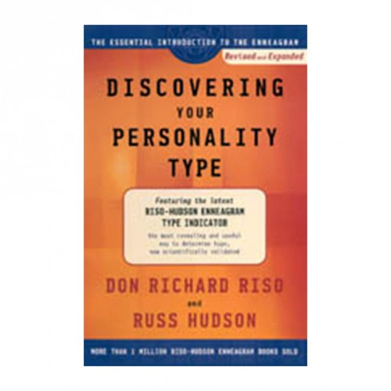

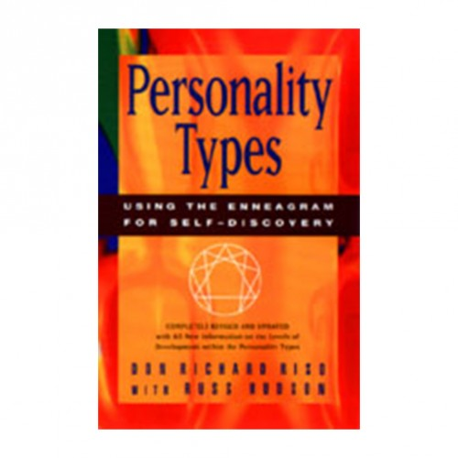

Secondly, read this book and study your personality type chapter 9 levels of integration and disintegration. This will give you a full picture of yourself becoming healthy or unhealthy.

Also you will come to know your basic fear and desire and how this creates an imbalance. Nonetheless it will no longer be a vice, but become a virtue when you acquire self knowledge, so you can make it useful to you rather than let it hinder you.

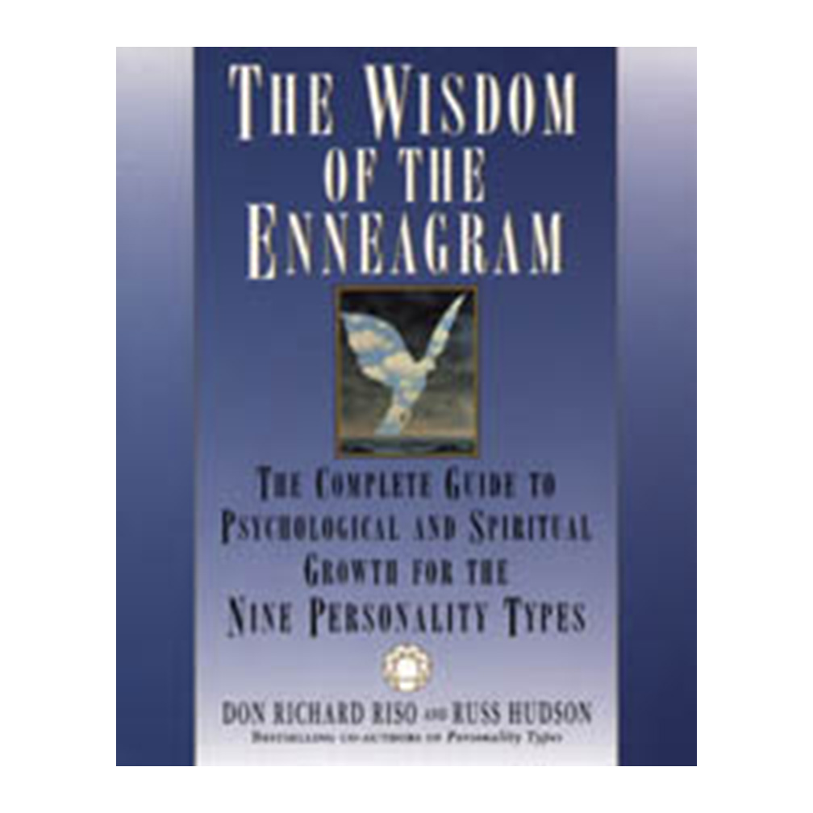
Thirdly, move onto this book and work with it and see how it further puts the work into perspective for you.

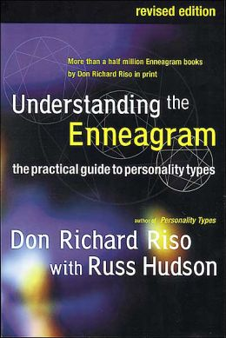

Fourthly, move onto this book which will go into all aspect of enneagram in a deeper way, so considering this remember to read this one lastly after you have gained more substance in the previous books.

Writing the enneagram self knowledge essay.

Step-By-Step Guide to Essay Writing

In the essay you need to demonstrate:

Self knowledge of how the 9 levels of disintegration relate to your own life.

How you plan to integrate your type and avoid disintegration?

How your childhood made you either: intellectual, emotional or instinctual type?

How your type can hinder you - or be made into a means of empowering your self and furthering will?

How you could use your type to assist a group or collective?

